PYTHON PROGRAMMING – CSA0805
K. Shalini (192512270)

TASK 1 – FILE-PROCESSING DESIGN REVIEW
Task 1.1 – Diagnose the Script
The given script has the following design deficiencies:
- Hard-coded file path: The file path is fixed in the program. If the file is moved to another location, the program will not work.
- File is not closed: The program does not close the file after reading. This may waste system resources.
- Reading the entire file: The read() method loads the complete file into memory. This may cause memory problems when processing large files.
- Bare except statement: The except: statement catches all errors without identifying the actual problem. This makes debugging difficult.
- Amounts with paise: Using int() cannot process decimal amounts such as 1250.50. It may reject valid bill records.
- Repeated string concatenation: Using report = report + ... repeatedly creates unnecessary string objects and reduces efficiency.
- Last empty line: If the file contains an empty line at the end, it may cause an indexing error.
- No rejected-record information: Invalid records are silently ignored because of pass. The hostel office cannot identify or correct rejected entries.
Task 1.2 – Repair the Design
Corrected Python Program
from decimal import Decimal, InvalidOperation
def calculate_mess_bill(filename):
total = Decimal("0.00")
report = []
rejected = []
with open(filename, "r", encoding="utf-8") as f:
for line_number, line in enumerate(f, start=1):
if not line.strip():
continue
try:
parts = line.strip().split(",")
if len(parts) != 3:
raise ValueError("Expected 3 fields")
reg_no = parts[0].strip()
name = parts[1].strip()
amount = Decimal(parts[2].strip())
total += amount
report.append(name + " " + str(amount))
except (ValueError, InvalidOperation) as e:
rejected.append((line_number, line.strip(), str(e)))
print("Mess Bill Report")
for item in report:
print(item)
print("Total:", total)
print("Rejected Records:")
for item in rejected:
print(item)
calculate_mess_bill("mess_oct.txt")
Explanation
- The with statement automatically closes the file.
- The function accepts the filename as a parameter.
- The file is processed one line at a time.
- Decimal() supports amounts containing paise.
- Specific exceptions identify invalid records.
- A list stores rejected records with their line numbers.
- Empty lines are skipped.
Task 1.3 – Design Defence
The corrected program is safer for a file containing 50,000 lines because it reads one line at a time instead of loading the entire file into memory. The with statement ensures that the file is closed automatically. Specific exception handling identifies invalid records, while the rejected list maintains a record of errors. Using Decimal also allows accurate processing of amounts containing paise.
Alternative Concept and Complexity Analysis
If read() or readlines() is used, the complete file is loaded into memory before processing.
Alternative code:
with open("mess_oct.txt", "r", encoding="utf-8") as f:
lines = f.readlines()
for line in lines:
print(line.strip())
Complexity comparison:
Method | Time Complexity | Extra Space Complexity
Line-by-line reading | O(n) | O(L)
Using read() or readlines() | O(n) | O(n)
Here, n represents the total file size and L represents the size of one line.
Both methods take O(n) time, but line-by-line reading uses less memory because it stores only one line at a time. This is more suitable for a file containing 50,000 records.
PYTHON CODE:
from decimal import Decimal, InvalidOperation
from io import StringIO
data = """192311001,Arun,1250.50
192311002,Priya,980.00
192311003,Ravi,1200.75
192311004,Kumar,abc
192311005,Divya
192311006,Meena,750.00
"""
def calculate_mess_bill(filename):
total = Decimal("0.00")
report = []
rejected = []

with StringIO(data) as file:
for line_number, line in enumerate(file, start=1):
if not line.strip():
continue
try:
parts = line.strip().split(",")
if len(parts) != 3:
raise ValueError("Expected 3 fields")
name = parts[1].strip()
amount = Decimal(parts[2].strip())
total += amount
report.append((name, amount))
except (ValueError, InvalidOperation) as e:
rejected.append((line_number, line.strip(), str(e)))
print("MESS BILL REPORT")
print("----------------")
for name, amount in report:
print(name, "-", amount)
print("----------------")
print("Total Mess Bill:", total)
print("\nREJECTED RECORDS")
print("----------------")
for item in rejected:
print(item)
calculate_mess_bill("mess_oct.txt")
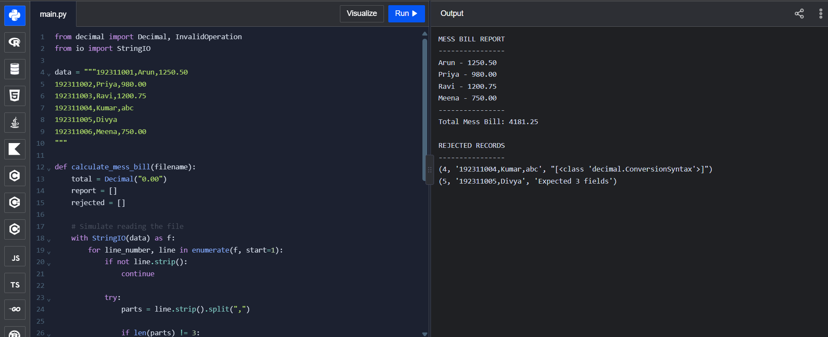

TASK 2 – FROM REQUIREMENT TO FILE-PROCESSING DESIGN
Task 2.1 – Model the Data
Input File Format:
Each line contains three fields separated by commas: register number, date and attendance status.
Example:
192311001,2026-10-08,P
192311002,2026-10-08,A
- P represents Present.
- A represents Absent.
Data Structures Used:
- Dictionary – Stores each student's present and absent counts.
- List – Stores damaged records with filenames and line numbers.
Output Files:
- attendance_report.txt – Stores attendance percentages and students below 75%.
- error_log.txt – Stores damaged records, filenames and line numbers.

Task 2.2 – Design the File Operations
File operation | Purpose
r | Read daily attendance files
w | Create the attendance report
w | Create the error log
utf-8 | Handle text encoding
open() | Open files
read() | Read file contents
write() | Write reports
File iteration | Process one line at a time
The with statement is used to close files automatically after processing.
Task 2.3 – Design the Processing
Pseudocode:
BEGIN
CREATE empty attendance dictionary
CREATE empty error list

GET all daily attendance filenames using pathlib
FOR each file:
OPEN file in read mode
FOR each line with line number:
SPLIT line using comma
IF number of fields is not 3:
RECORD filename and line number
CONTINUE
EXTRACT register number, date and status
IF status is not P or A:
RECORD filename and line number
CONTINUE
IF register number is not in dictionary:
CREATE present and absent counters
IF status is P:
INCREMENT present count
ELSE:
INCREMENT absent count
CLOSE all files
FOR each student:
CALCULATE attendance percentage
IF percentage is below 75:
ADD student to below-75% list
WRITE attendance details to attendance_report.txt
WRITE damaged records to error_log.txt
END
Task 2.4 – Trace
Sample Input File: day1.txt
192311001,2026-10-08,P
192311002,2026-10-08,A
192311003,2026-10-08
192311004,2026-10-08,P
Trace Table:
Line | Register Number | Status | Result
1 | 192311001 | P | Present count = 1
2 | 192311002 | A | Absent count = 1
3 | 192311003 | Missing | Recorded as damaged
4 | 192311004 | P | Present count = 1
The third line is rejected because it contains only two fields instead of three.
Alternative Concept and Complexity Analysis
If each student's attendance were calculated by reading all daily files separately, the same files would be scanned repeatedly.
In the dictionary-based method, each file is read once and the attendance counts are updated immediately.
Method | Time Complexity | Space Complexity
Re-reading files for every student | O(s × f × l) | O(1) extra counting space
Dictionary-based processing | O(f × l) average | O(s)
Here, s represents the number of students, f the number of files and l the number of lines per file.
The dictionary-based method is more efficient because it avoids repeatedly reading the same files.
PYTHON CODE:
from io import StringIO
daily_files = {
"day1.txt": """192311001,2026-10-08,P
192311002,2026-10-08,A
192311003,2026-10-08
192311004,2026-10-08,P
""",
"day2.txt": """192311001,2026-10-09,P
192311002,2026-10-09,A
192311003,2026-10-09,P
192311004,2026-10-09,A
""",
"day3.txt": """192311001,2026-10-10,A
192311002,2026-10-10,P
192311003,2026-10-10,P
192311004,2026-10-10,L
"""
}
attendance = {}
errors = []
for filename, content in daily_files.items():
with StringIO(content) as file:
for line_number, line in enumerate(file, start=1):

if not line.strip():
continue
parts = line.strip().split(",")
if len(parts) != 3:
errors.append(
(filename, line_number, "Invalid number of fields")
)
continue
reg_no, date, status = [x.strip() for x in parts]
if status not in ("P", "A"):
errors.append(
(filename, line_number, "Invalid status")
)
continue
if reg_no not in attendance:
attendance[reg_no] = {
"present": 0,
"absent": 0
}
if status == "P":
attendance[reg_no]["present"] += 1
else:
attendance[reg_no]["absent"] += 1
print("MONTHLY ATTENDANCE REPORT")
print("-------------------------")
below_75 = []
for reg_no in sorted(attendance):
present = attendance[reg_no]["present"]
absent = attendance[reg_no]["absent"]
total = present + absent
percentage = (present / total) * 100
print("Register Number:", reg_no)
print("Present:", present)
print("Absent:", absent)
print("Percentage:", round(percentage, 2), "%")
print()
if percentage < 75:
below_75.append(reg_no)
print("STUDENTS BELOW 75%")
print("------------------")
for reg_no in below_75:
print(reg_no)
print("\nDAMAGED RECORDS")
print("----------------")
for error in errors:
print(error)
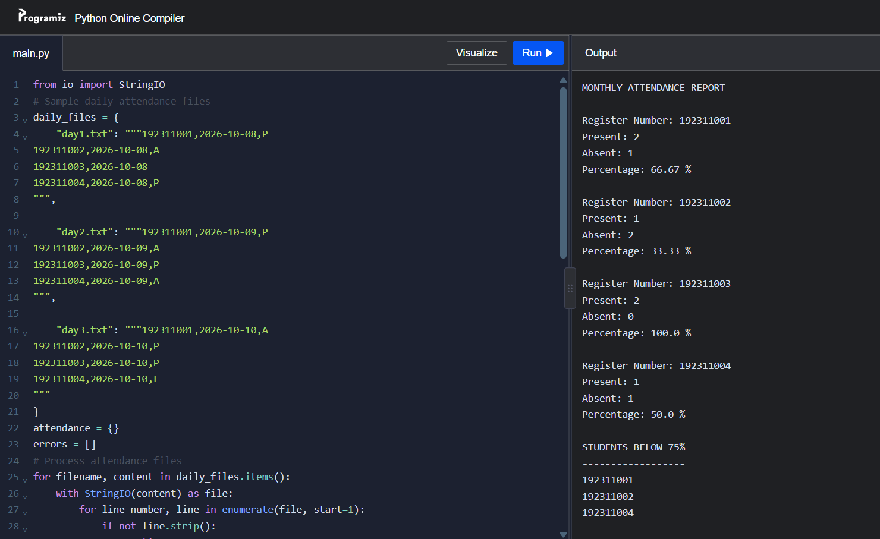
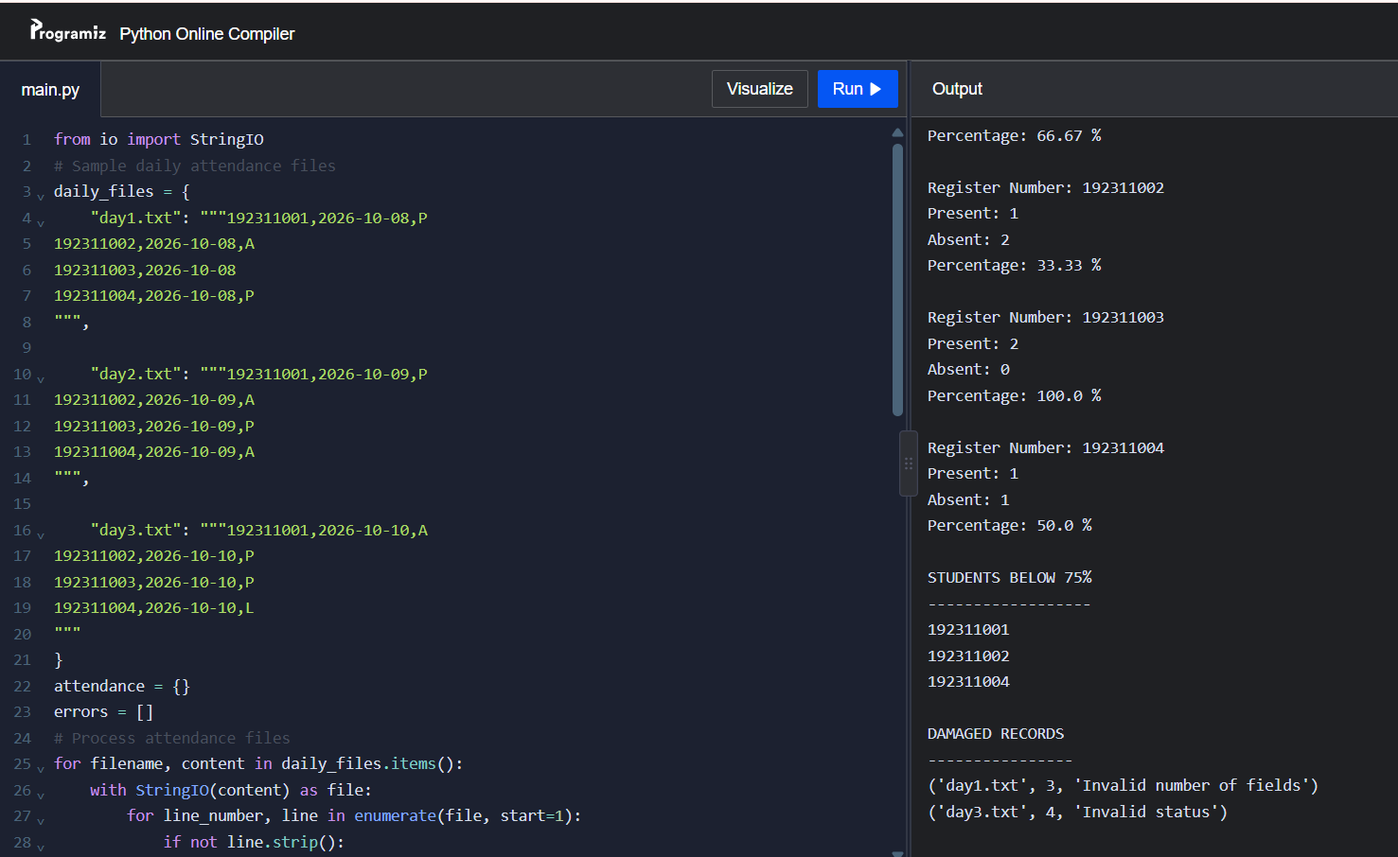

TASK 3 – DESIGN THE ERROR HANDLING
Task 3.1 – Identify the Failures
Failure | Exception Raised
Folder does not exist | FileNotFoundError
File does not exist | FileNotFoundError
Permission denied | PermissionError
Incorrect text encoding | UnicodeDecodeError
Missing fields in a record | InvalidRecord
Invalid attendance status | InvalidRecord
Invalid numeric conversion | ValueError
Accessing a missing list element | IndexError
Empty file | No exception automatically; the program must check for it
Task 3.2 – Design a Custom Exception
A custom exception named InvalidRecord is created to identify damaged attendance records.
- It is raised inside the parse_line() function when a line does not contain exactly three fields or has an invalid attendance status.
- It is handled inside the summarise() function using an except InvalidRecord block.
- The invalid line number and error message are stored in an error list.
Task 3.3 – Use the Complete try Statement
The program uses the following statements:
- try – Executes file-processing operations.
- except – Handles specific errors.
- else – Executes when no exception occurs.
- finally – Executes whether an exception occurs or not.
- raise ... from ... – Preserves the original cause of an exception.
PYTHON PROGRAM
class InvalidRecord(Exception):
"""Raised when an attendance record is invalid."""
def parse_line(line):
parts = line.strip().split(",")
try:
if len(parts) != 3:
raise ValueError(
f"expected 3 fields, found {len(parts)}"
)
if parts[2] not in ("P", "A"):
raise ValueError(
f"invalid status '{parts[2]}'"
)
return tuple(parts)
except ValueError as e:
raise InvalidRecord(str(e)) from e
def summarise(path, data=None):
present = 0
absent = 0
errors = []
try:
from io import StringIO
if data is not None:
file = StringIO(data)
else:
file = open(path, "r", encoding="utf-8")
with file:
for line_number, line in enumerate(file, start=1):
if not line.strip():
continue
try:
reg_no, date, status = parse_line(line)

if status == "P":
present += 1
else:
absent += 1
except InvalidRecord as e:
errors.append((line_number, str(e)))
except FileNotFoundError:
print("Error: File not found.")
except PermissionError:
print("Error: Permission denied.")
except UnicodeDecodeError:
print("Error: Incorrect file encoding.")
else:
print("File processed successfully.")
finally:
print("Processing completed.")
return present, absent, errors
data = (
"192311001,2026-10-08,P\n"
"192311002,2026-10-08,A\n"
"192311003,2026-10-08\n"
"192311004,2026-10-08,L\n"
)
print(summarise("attendance.csv", data))
print("\nTesting missing file:")
print(summarise("missing_file.csv"))
Expected Output
File processed successfully.
Processing completed.
(1, 1, [(3, 'expected 3 fields, found 2'), (4, "invalid status 'L'")])
Testing missing file:
Error: File not found.
Processing completed.
None
Task 3.4 – Misuse Experiment
Experiment:
Replace specific exception handling with:
except Exception:
pass
Then introduce a typing error in a variable name.
Observation: The program does not display the error message because the broad exception handler catches the error and silently ignores it.
Explanation: Using except Exception: pass hides programming errors and makes debugging difficult. Specific exception handling is safer because it identifies the actual problem.
Alternative Concept and Complexity Analysis
Another approach is to validate every line using if statements before processing it instead of raising and catching exceptions.

Method | Time Complexity | Explanation
Exception handling | O(1) per line on average | Suitable when invalid records are rare
If-statement validation | O(1) per line | Checks each record before processing
Both methods take O(n) time for n records. When invalid records are rare, exception handling is convenient. When invalid records are common, using if statements avoids repeated exception-handling overhead.
Conclusion
Custom exceptions help identify invalid attendance records clearly. Specific exception handling makes the program more reliable, while else and finally provide proper execution flow and cleanup. The experiment also shows why broad exception handling should be avoided.
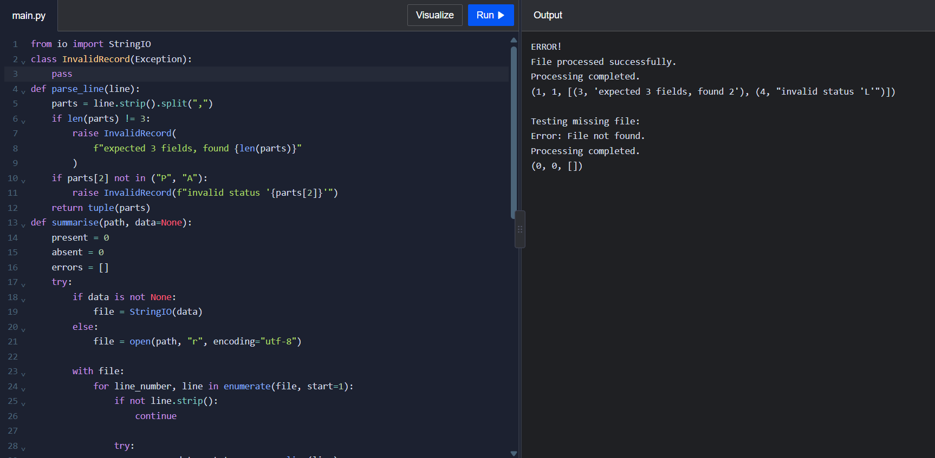

TASK 4 – FILE AND EXCEPTION FORENSICS
4.1 Identify the Problems in the Given Code
The given program has the following problems:
- File overwriting: The file is opened using "w" mode, which removes the previous contents whenever the program runs.
- Missing newline: The write() method does not add a newline after each book record, so records may join together.
- File closing issue: If an error occurs before log.close(), the file may remain open.
- Incomplete exception handling: The program handles only FileNotFoundError and ignores other possible errors.
- Poor error reporting: The program prints only "missing" and does not record the filename or error details.
4.2 Test the Given Code
The program is tested using three daily book-return lists.
- Day 1: Book101, Book102
- Day 2: Book103, Book104
- Day 3: Book105, Book106
Since the file is opened in write mode, only the third day's records remain in the file.
4.3 Corrected Code
def save_returns(books):
try:
with open("returns.log", "a", encoding="utf-8") as log:
for book in books:
log.write(book + "\n")

except OSError as e:
with open("error.log", "a", encoding="utf-8") as error:
error.write(str(e) + "\n")
def process(day_file):
try:
with open(day_file, "r", encoding="utf-8") as file:
books = file.read().splitlines()
save_returns(books)
except FileNotFoundError:
with open("error.log", "a", encoding="utf-8") as error:
error.write(day_file + ": File not found\n")
except PermissionError:
with open("error.log", "a", encoding="utf-8") as error:
error.write(day_file + ": Permission denied\n")
process("day1.txt")
process("day2.txt")
process("day3.txt")
Improvements:
- "a" mode preserves previous records.
- "\n" separates each book record.
- with automatically closes files.
- Specific exceptions handle file errors.
- Error messages are stored in error.log.
4.4 Two Important File-Handling Rules
- Always use the with statement when opening files because it automatically closes the file, even if an error occurs.
- Select the correct file mode. Use "r" for reading, "w" for writing and "a" for appending records.
Alternative Approach and Complexity
File handling can also be performed using open() and close() with a try-finally block. However, the with statement is simpler and safer.
Both approaches have O(n) time complexity for processing n book records. Their memory usage depends on how the records are read and stored.
Expected File Outputs
After running the corrected program with the following sample files:
day1.txt
Book101
Book102
day2.txt
Book103
Book104
day3.txt
Book105
Book106
Expected output – returns.log
Book101
Book102
Book103
Book104
Book105
Book106
Expected output – error.log
If all three daily files are available and there are no errors, the error.log file remains empty.
If a daily file is missing, for example, day2.txt, the error log contains:
day2.txt: File not found
Two Important File-Handling Rules
- Always use the with statement to ensure files are closed automatically.
- Choose the correct file mode: "r" for reading, "w" for writing and "a" for appending.
PYTHON CODE:
from io import StringIO
daily_files = {
"day1.txt": "Book101\nBook102\n",
"day2.txt": "Book103\nBook104\n",
"day3.txt": "Book105\nBook106\n"
}
returns_log = []
error_log = []
def save_returns(books):
for book in books:
returns_log.append(book)
def process(day_file):
try:
if day_file not in daily_files:
raise FileNotFoundError
with StringIO(daily_files[day_file]) as file:
books = file.read().splitlines()
save_returns(books)
except FileNotFoundError:
error_log.append(day_file + ": File not found")
except PermissionError:
error_log.append(day_file + ": Permission denied")
process("day1.txt")
process("day2.txt")
process("day3.txt")
print("RETURNS LOG")
print("-----------")
for book in returns_log:
print(book)
print("\nERROR LOG")
print("----------")
if error_log:
for error in error_log:
print(error)
else:
print("No errors found.")
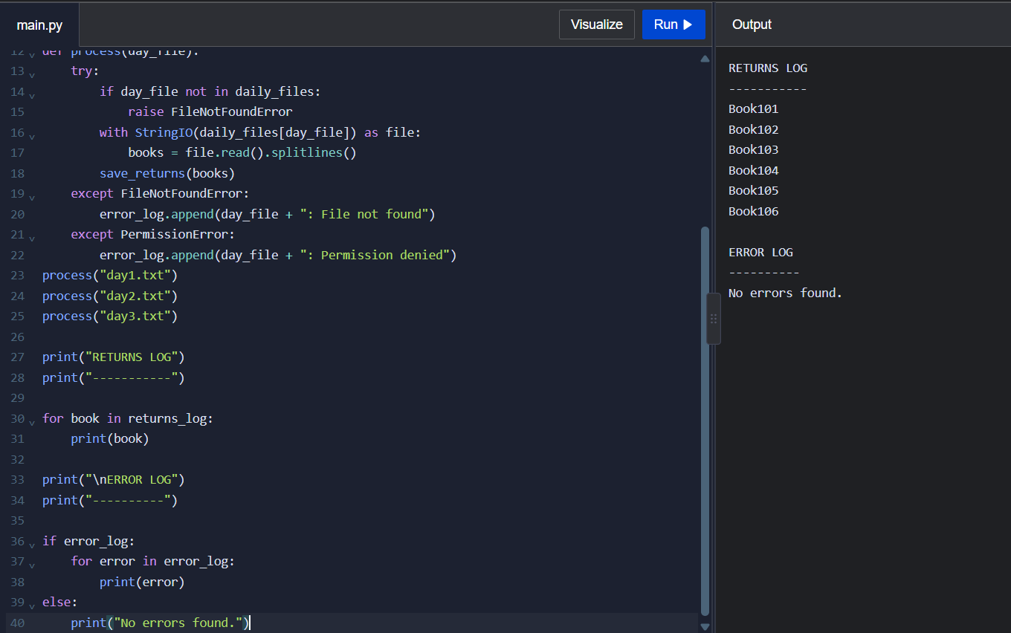

TASK 5 – ORGANISING CODE USING MODULES AND PACKAGES
5.1 Organising the Attendance Processor in Four Ways
An attendance processor contains three main functions:
- Reading: Reads attendance records from files.
- Statistics: Calculates present days, absent days and attendance percentage.
- Report: Generates attendance reports.
The program can be organised in four ways:
a) Single Python Script
All three functions are written in one Python file.
Example: attendance.py
Advantages:
- Easy to create and execute.
- Suitable for small programs.
Disadvantage:
- Difficult to maintain when the program becomes large.
b) One Module Imported by a Main Program
Create a module named attendance.py containing all three functions and import it into main.py.
Example:
import attendance
attendance.read_file()
attendance.calculate_statistics()
attendance.generate_report()
Advantages:
- Code can be reused.
- Main program becomes simpler.
c) Three Separate Modules
Organise the functions into three Python files:
- reader.py – reads attendance files.
- stats.py – calculates attendance statistics.
- report.py – generates reports.
The main program imports the required modules.
Advantages:
- Easy to understand and maintain.
- Each module performs a separate task.
d) Python Package
Create a package named attendance with the following structure:
attendance/
__init__.py
reader.py
stats.py
report.py
main.py
The __init__.py file identifies the folder as a Python package.
Example:
from attendance.reader import read_file
from attendance.stats import calculate_statistics
from attendance.report import generate_report
Advantages:
- Better organisation for large projects.
- Supports code reuse and easier maintenance.
The if __name__ == "__main__": condition is used to execute code only when a Python file is run directly.
5.2 Adding a New Report Feature
A new feature is added to identify students who are absent for three consecutive days.
The program checks each student's attendance records and identifies three continuous absent days.
This feature can be added as follows:
Organisation | Files to be changed
Single script | 1 file
One module and main program | 1 module
Three separate modules | 2 files
Package structure | 1 module and main program
The number of files changed may vary depending on the existing program design.
5.3 Comparison of the Four Approaches
Feature | Single Script | One Module | Three Modules | Package
Readability | Low for large code | Good | Very good | Very good
Reusability | Low | Good | High | High
Testing | Difficult | Easier | Easier | Easier
Maintenance | Difficult | Moderate | Easy | Easy
Import Statements
- import attendance.stats – imports the stats module using its full module name.
- from attendance import stats – imports the stats module from the attendance package.
- from attendance.stats import percentage – imports the percentage function directly.
Alternative Approach and Complexity
All functions can also be written in a single Python script. This approach is suitable for small projects but becomes difficult to manage as the program grows.
Python loads imported modules and generally caches them in sys.modules, avoiding repeated loading of the same module during the same program execution.
Using modules and packages improves readability, testing and code maintenance. The actual attendance calculation complexity depends on the number of student records and attendance days.
PYTHON CODE:
from io import StringIO
def read_file(data):
attendance = {}
with StringIO(data) as file:
for line in file:
reg_no, date, status = line.strip().split(",")
if reg_no not in attendance:
attendance[reg_no] = []
attendance[reg_no].append(status)
return attendance
def calculate_statistics(attendance):
for reg_no, records in attendance.items():
present = records.count("P")
absent = records.count("A")
percentage = (present / len(records)) * 100
print("Register Number:", reg_no)
print("Present:", present)
print("Absent:", absent)
print("Attendance:", round(percentage, 2), "%")
print()
def find_three_absent(attendance):
print("Students absent for three consecutive days:")
found = False
for reg_no, records in attendance.items():
for i in range(len(records) - 2):
if records[i:i + 3] == ["A", "A", "A"]:
print(reg_no)
found = True
break
if not found:
print("No students found.")
def generate_report(attendance):
print("ATTENDANCE REPORT")
print("-----------------")
calculate_statistics(attendance)
find_three_absent(attendance)
data = """192311001,2026-10-08,P
192311001,2026-10-09,A
192311001,2026-10-10,A
192311001,2026-10-11,A
192311002,2026-10-08,A
192311002,2026-10-09,P
192311002,2026-10-10,A
192311002,2026-10-11,P
"""
attendance = read_file(data)
generate_report(attendance)
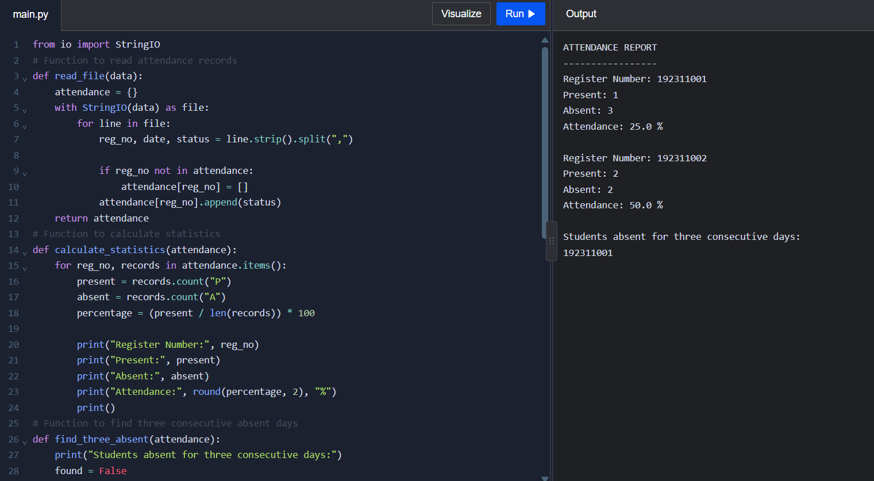

TASK 6 – COLLEGE FEST REGISTRATION DESK DESIGN CHALLENGE
Stage 1 – Input, Output and Validation Rules
The College Fest Registration Desk collects registration details from five departments.
Input format:
Each line contains:
- Register Number
- Student Name
- Department
- Email Address
- Events (separated by semicolons)
Example:
192311001,Arun,CSE,arun@gmail.com,Dance;Singing
Expected outputs:
- Clean master registration list.
- Separate participant files for each event.
- Summary report containing registration details.
- Error log containing invalid and damaged records.
Validation rules:
- Register number must not be empty.
- Student name and department must be provided.
- Email must contain @ and a valid-looking domain.
- Event names must not be empty.
- Duplicate registrations must be rejected.
- Damaged records must be recorded in the error log.
Stage 2 – Processing Workflow
The system follows these steps:
- Read registration files from all five departments.
- Read each record line by line.
- Split the record into fields.
- Validate the registration details.
- Check for duplicate register numbers.
- Store valid registrations in a master list.
- Separate participants according to their events.
- Generate event-wise participant files.
- Generate a summary report.
- Save invalid records and errors in an error log.
The program should continue processing even if one record is invalid or a department file is missing.
Stage 3 – Data Structures and Exception Handling
Data structures used:
- List – stores valid student registrations.
- Set – identifies duplicate register numbers.
- Dictionary – stores event-wise participants.
- String – stores student details and event names.
Email validation:
String methods such as split(), strip() and endswith() can be used to check email format.
Exception handling:
- FileNotFoundError – handles missing department files.
- PermissionError – handles file access problems.
- ValueError – handles invalid records.
- InvalidRecord – custom exception for damaged registration details.
Invalid records are stored in the error log instead of stopping the program.
Stage 4 – Package Structure
The project can be organised using Python modules and packages.
college_fest/
__init__.py
reader.py
validation.py
registration.py
report.py
main.py
department_cse.txt
department_ece.txt
department_eee.txt
department_mech.txt
department_it.txt
Functions:
- read_files() – reads department registration files.
- validate_record() – checks registration details.
- check_duplicate() – identifies duplicate registrations.
- generate_event_files() – creates event-wise participant files.
- generate_summary() – generates the final summary report.
- write_error_log() – records invalid records and file errors.
Stage 5 – Testing and Expected Results
The system should be tested using the following cases:
Test case | Expected result
Valid registration | Added to master list
Duplicate registration | Rejected and logged
Invalid email | Rejected and logged
Damaged record | Rejected and logged
Missing department file | Error recorded; processing continues
Multiple events | Student added to each relevant event file
Expected output files:
- master_list.txt – contains all valid unique registrations.
- dance.txt – contains students registered for dance.
- singing.txt – contains students registered for singing.
- summary.txt – contains registration statistics.
- error.log – contains invalid records and errors.
Alternative Approach and Complexity
A list can be used to check duplicate registrations, but searching through a list takes O(n) time for each registration. A set provides average O(1) lookup time.
Therefore, using a set for duplicate detection is more efficient when processing a large number of registrations.
The system improves data accuracy, reduces duplicate entries and makes college fest registration easier to manage.
PYTHON CODE:
from io import StringIO
class InvalidRecord(Exception):
pass
department_files = {
"CSE.txt": """192311001,Arun,CSE,arun@gmail.com,Dance;Singing
192311002,Priya,CSE,priya@gmail.com,Dance
""",
"ECE.txt": """192311001,Arun,ECE,arun@gmail.com,Music
192311003,Ravi,ECE,ravi@gmail.com,Singing
""",
"EEE.txt": """192311004,Kumar,EEE,kumar123,Dance
192311005,Meena,EEE,meena@gmail.com,Music
""",
"MECH.txt": """192311006,Divya,MECH,divya@gmail.com
"""
}
master_list = []
registered_ids = set()
event_participants = {}
error_log = []
def validate_record(line):
parts = line.strip().split(",")
if len(parts) != 5:
raise InvalidRecord("Damaged record")
reg_no, name, department, email, events = [
item.strip() for item in parts
]

if not reg_no or not name or not department:
raise InvalidRecord("Missing student details")
if "@" not in email or "." not in email.split("@")[-1]:
raise InvalidRecord("Invalid email")
event_list = events.split(";")
if any(not event.strip() for event in event_list):
raise InvalidRecord("Invalid event name")
return reg_no, name, department, email, [
event.strip() for event in event_list
]
def read_files():
departments = [
"CSE.txt",
"ECE.txt",
"EEE.txt",
"MECH.txt",
"IT.txt"
]
for filename in departments:
try:
if filename not in department_files:
raise FileNotFoundError
with StringIO(department_files[filename]) as file:
for line_number, line in enumerate(file, start=1):
if not line.strip():
continue
try:
record = validate_record(line)
reg_no, name, dept, email, events = record
if reg_no in registered_ids:
raise InvalidRecord(
"Duplicate registration"
)
registered_ids.add(reg_no)
master_list.append(
f"{reg_no},{name},{dept},{email}"
)
for event in events:
if event not in event_participants:
event_participants[event] = []
event_participants[event].append(name)
except InvalidRecord as e:
error_log.append(
f"{filename}, Line {line_number}: {e}"
)
except FileNotFoundError:
error_log.append(
f"{filename}: File not found"
)
def generate_reports():
print("MASTER REGISTRATION LIST")
print("------------------------")
for record in master_list:
print(record)
print("\nEVENT-WISE PARTICIPANTS")
print("----------------------")
for event, students in event_participants.items():
print(event + ".txt")
for student in students:
print(student)
print("\nSUMMARY REPORT")
print("--------------")
print("Total valid registrations:", len(master_list))
print("Total events:", len(event_participants))
print("\nERROR LOG")
print("---------")
for error in error_log:
print(error)
read_files()
generate_reports()


